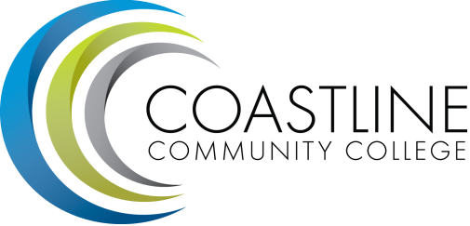

Classified Senate Meeting Agenda
Thursday, August 20, 2015
10AM-12PM
4th floor conference room, College Center

CALL TO ORDER (5 minutes)
  - Roll Call
  - Welcome: Mark W.
  - Adoption of Agenda
  - Approval of Minutes

SPECIAL REPORTS/UPDATES (5 minutes)
  - College Events
Jamba Juice - Monday, August 24th.
Gerontology Networking Event: September 1, 6:30 PM - 8:30 PM at the NBC

ACTION ITEMS (40 minutes)
  - Fundraising discussion
    - Jamba Juice
    - Fall Festival, Friday, October 30
    - Holiday Boutique (dates?)

STANDING REPORTS (10 minutes)
  - Committee Reports:
  - Academic Senate Report: Marilyn Fry
  - ASG Report: Andy Vu

DISCUSSION ITEMS (10 minutes)
  - Classified Senate Goals for 2015 - 2016
  - Committee Assignments

ANNOUNCEMENTS (5 minutes)

ADJOURNMENT

Next Meeting: September 17, 2015 10am to noon.

